**Aluminum fin supported PV panel dielectric liquid cooling**

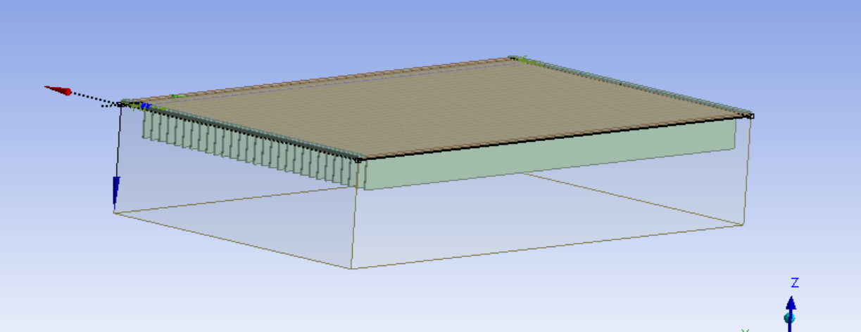

Instead of regular supports for solar panel, aluminum fin extended support with liquid cooling was designed in this project.  
Two different cooling techniques were compared. Static liquid cooling and dynamic liquid cooling will be analysed in next phase to understand the requirements and cooling efficiencies achieved by them. |51.52,4.08,0.42,15.08

Dielectric liquid material properties: 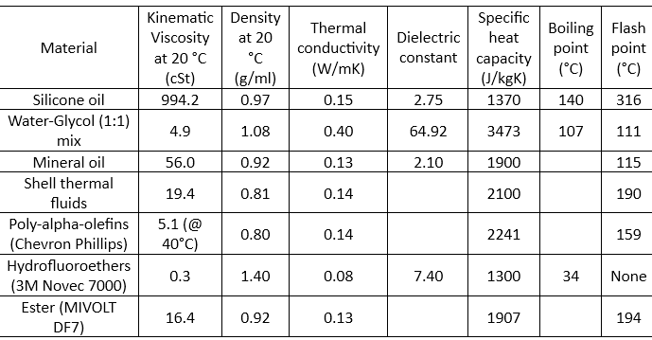

There will also be an analysis comparing some of the widely used dielectric single phase liquid coolants and the one which is giving good results will be used for the final comparison between static and dynamic cooling (free and forced convection).

Analysis results:

**Only PV panel temperature analysis (Default)**

**8am**

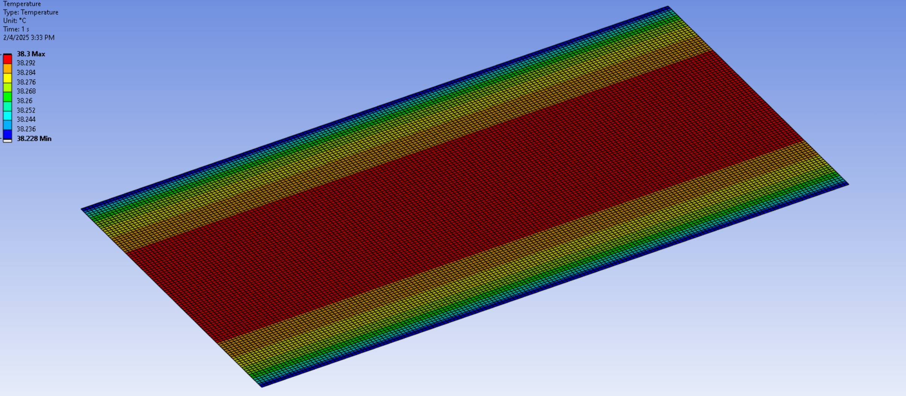

**9 am**

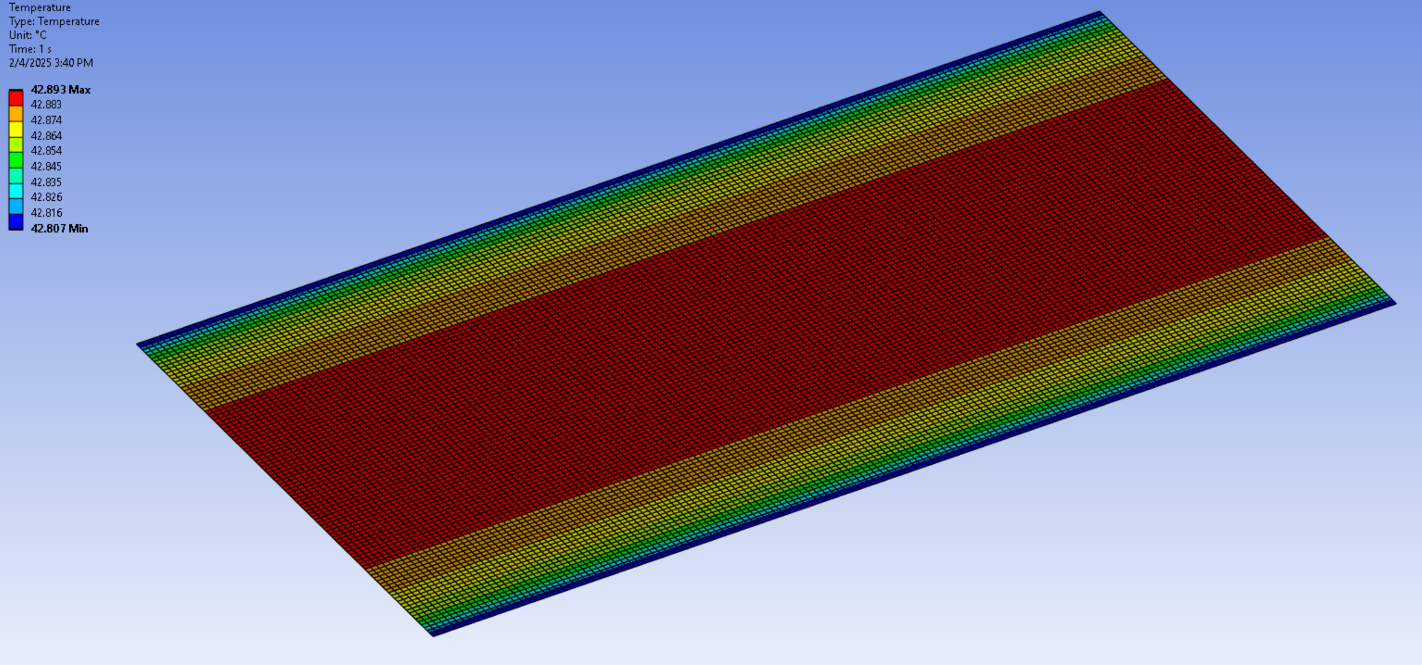

**10 am  
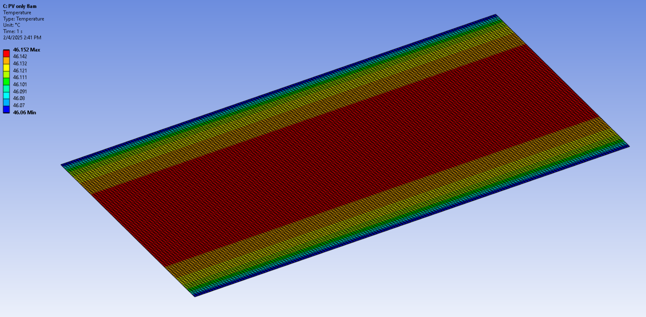**

**11 am**

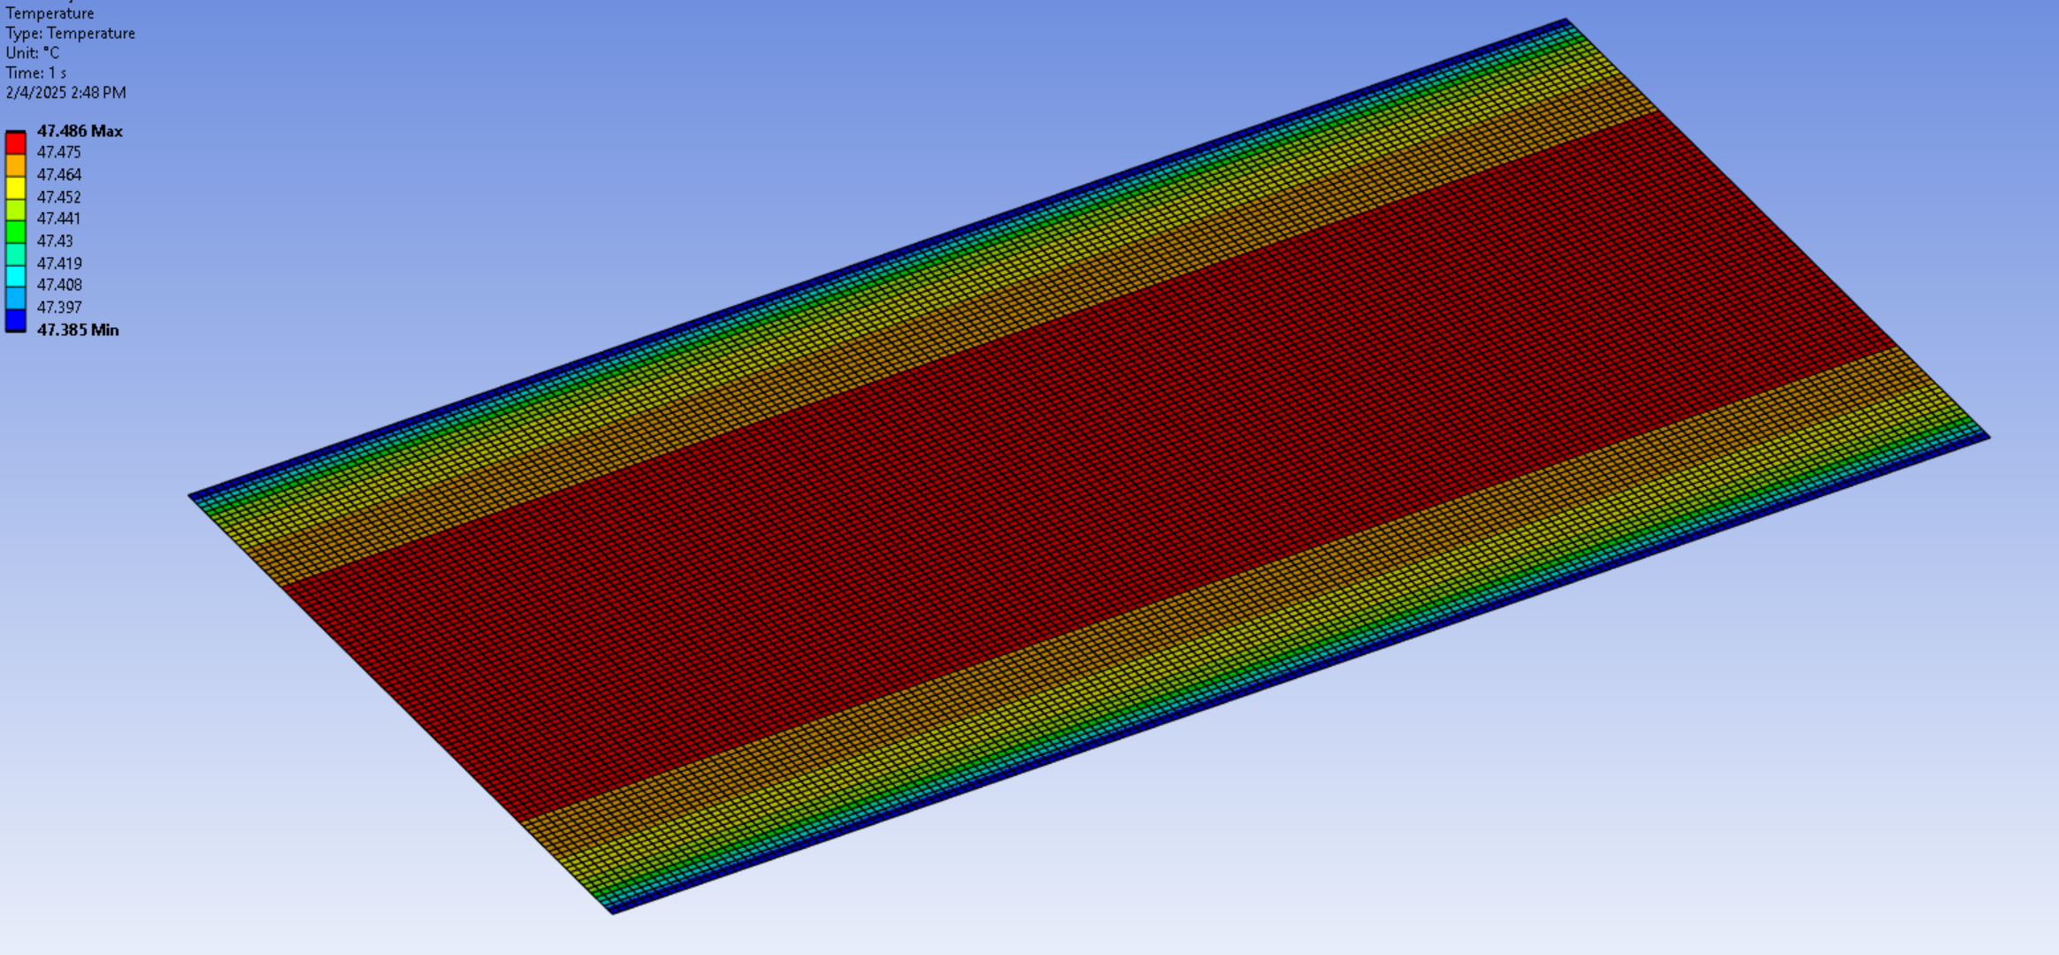

**12pm**

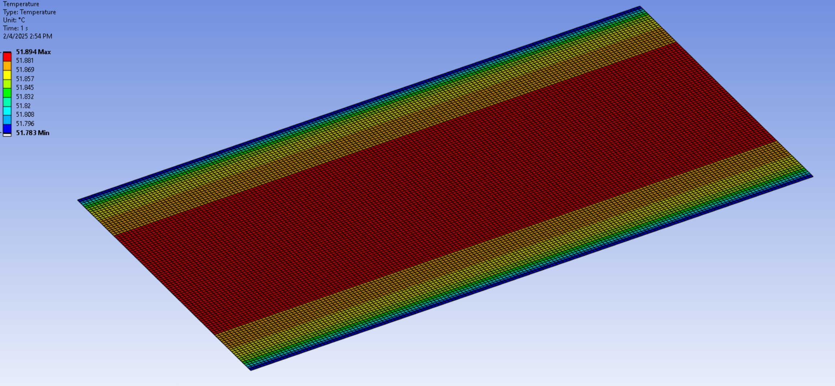

**1pm**

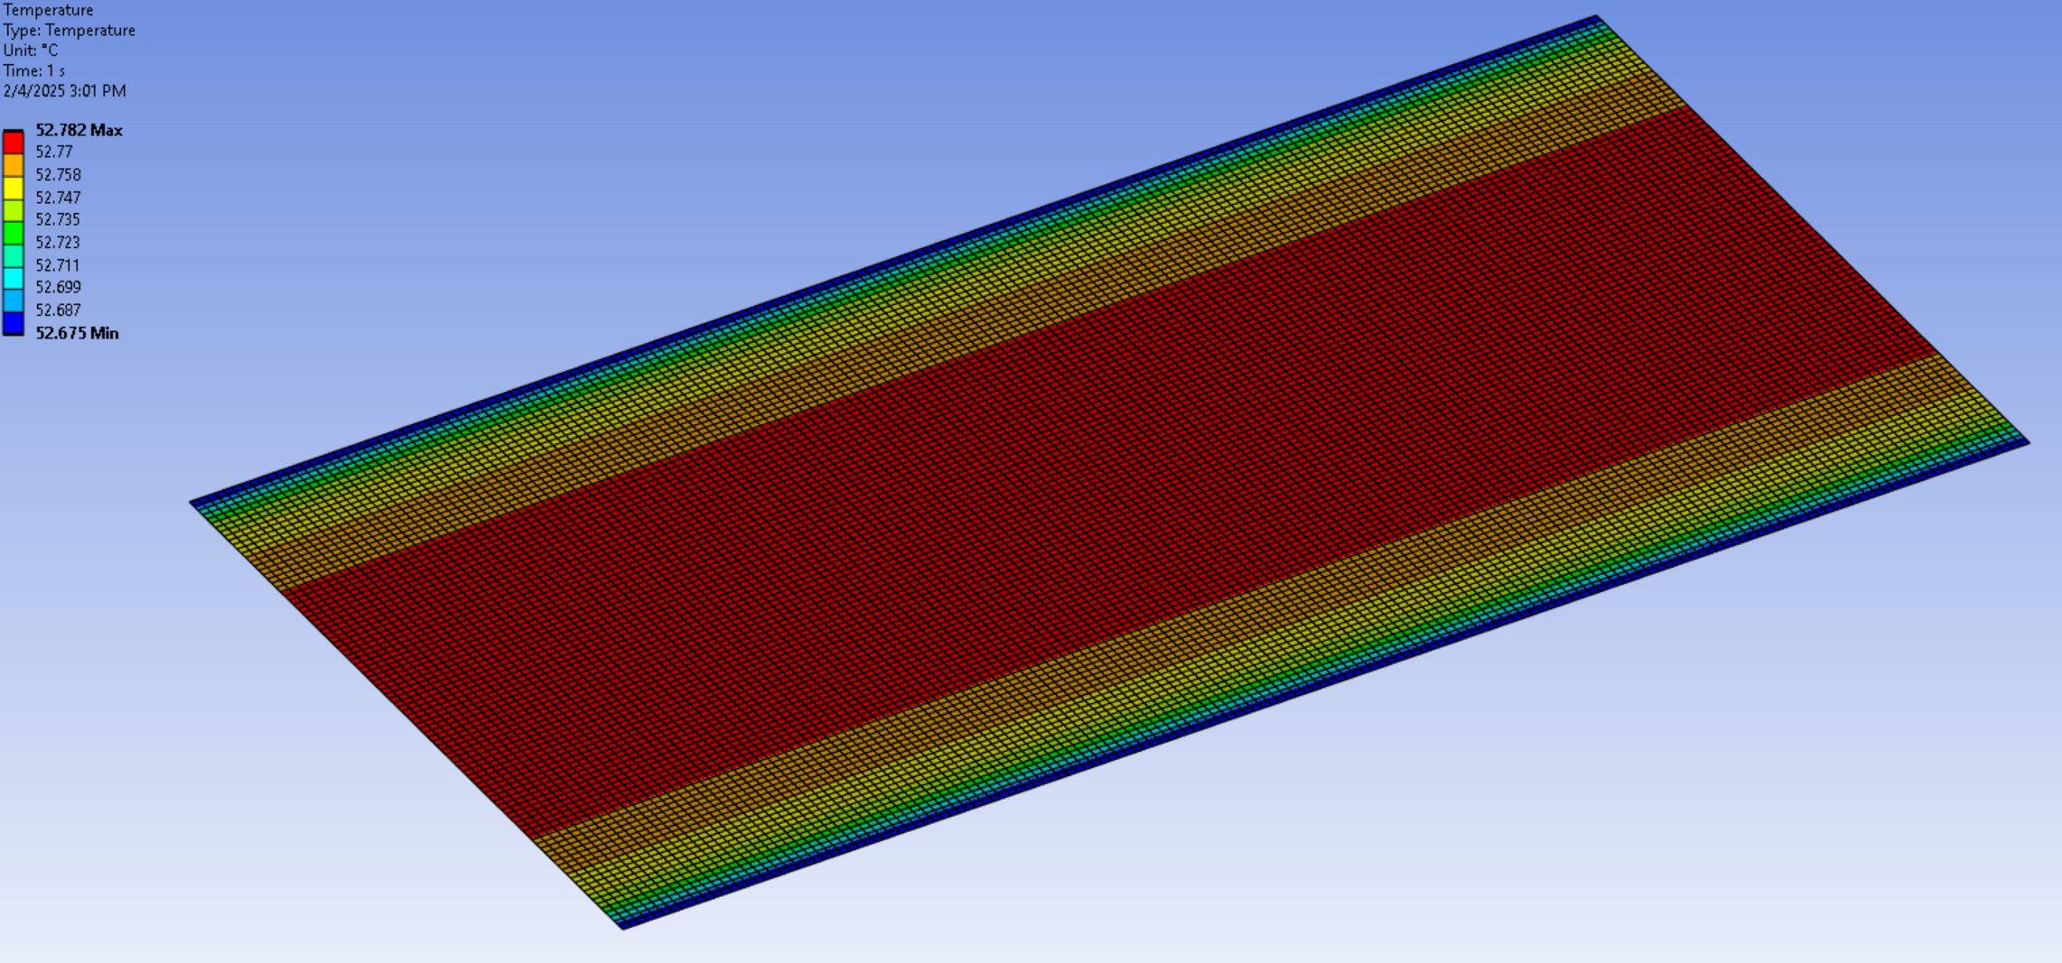

**2pm**

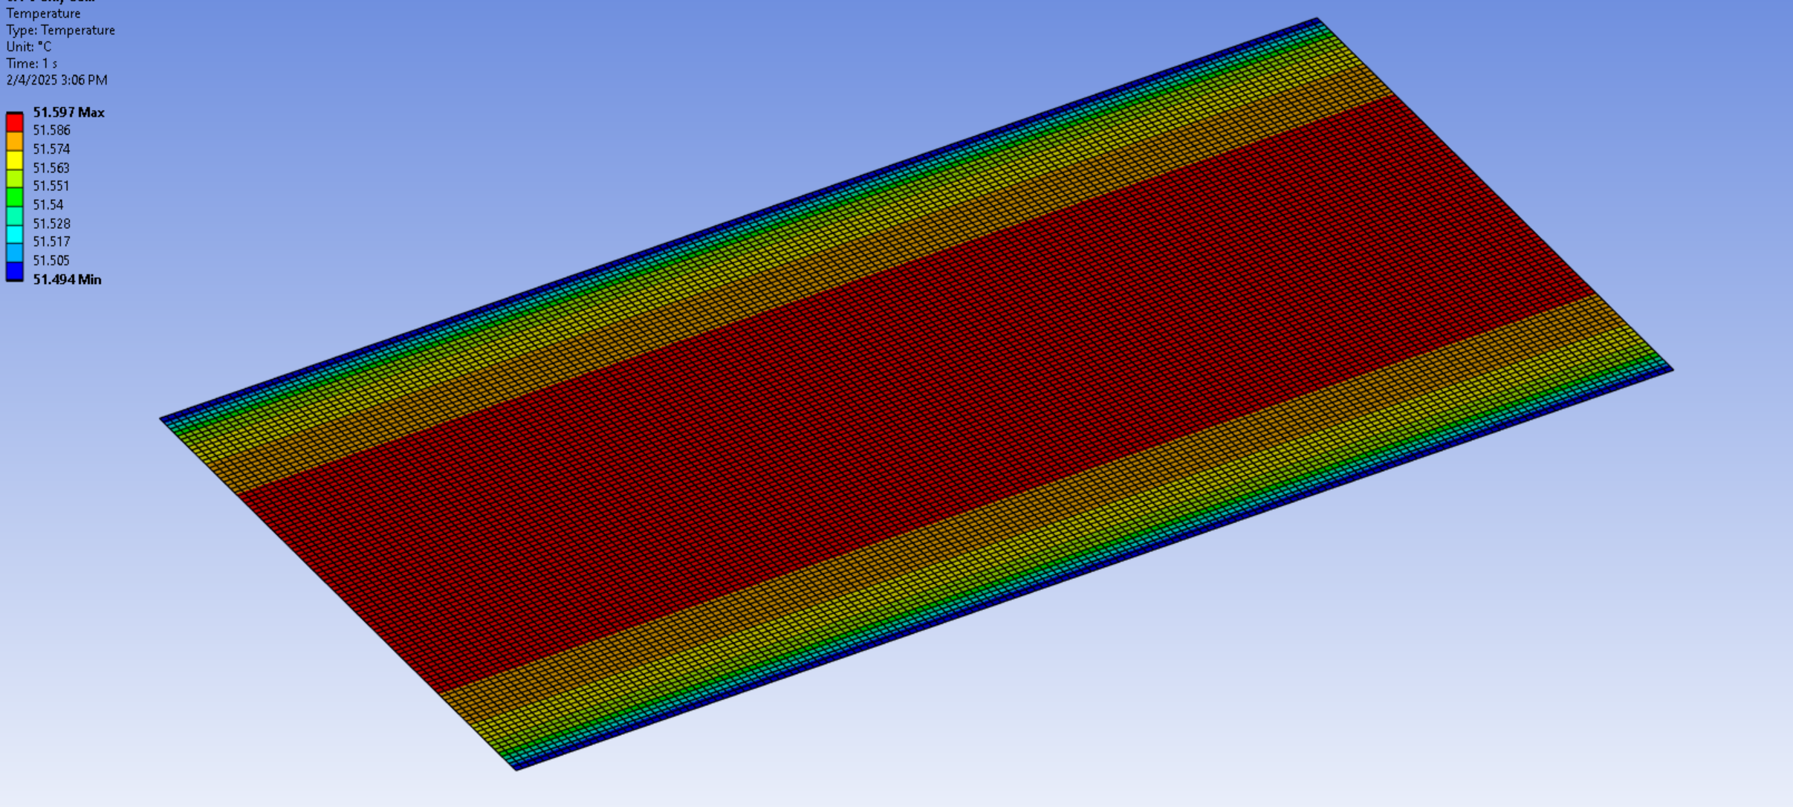

**3pm**

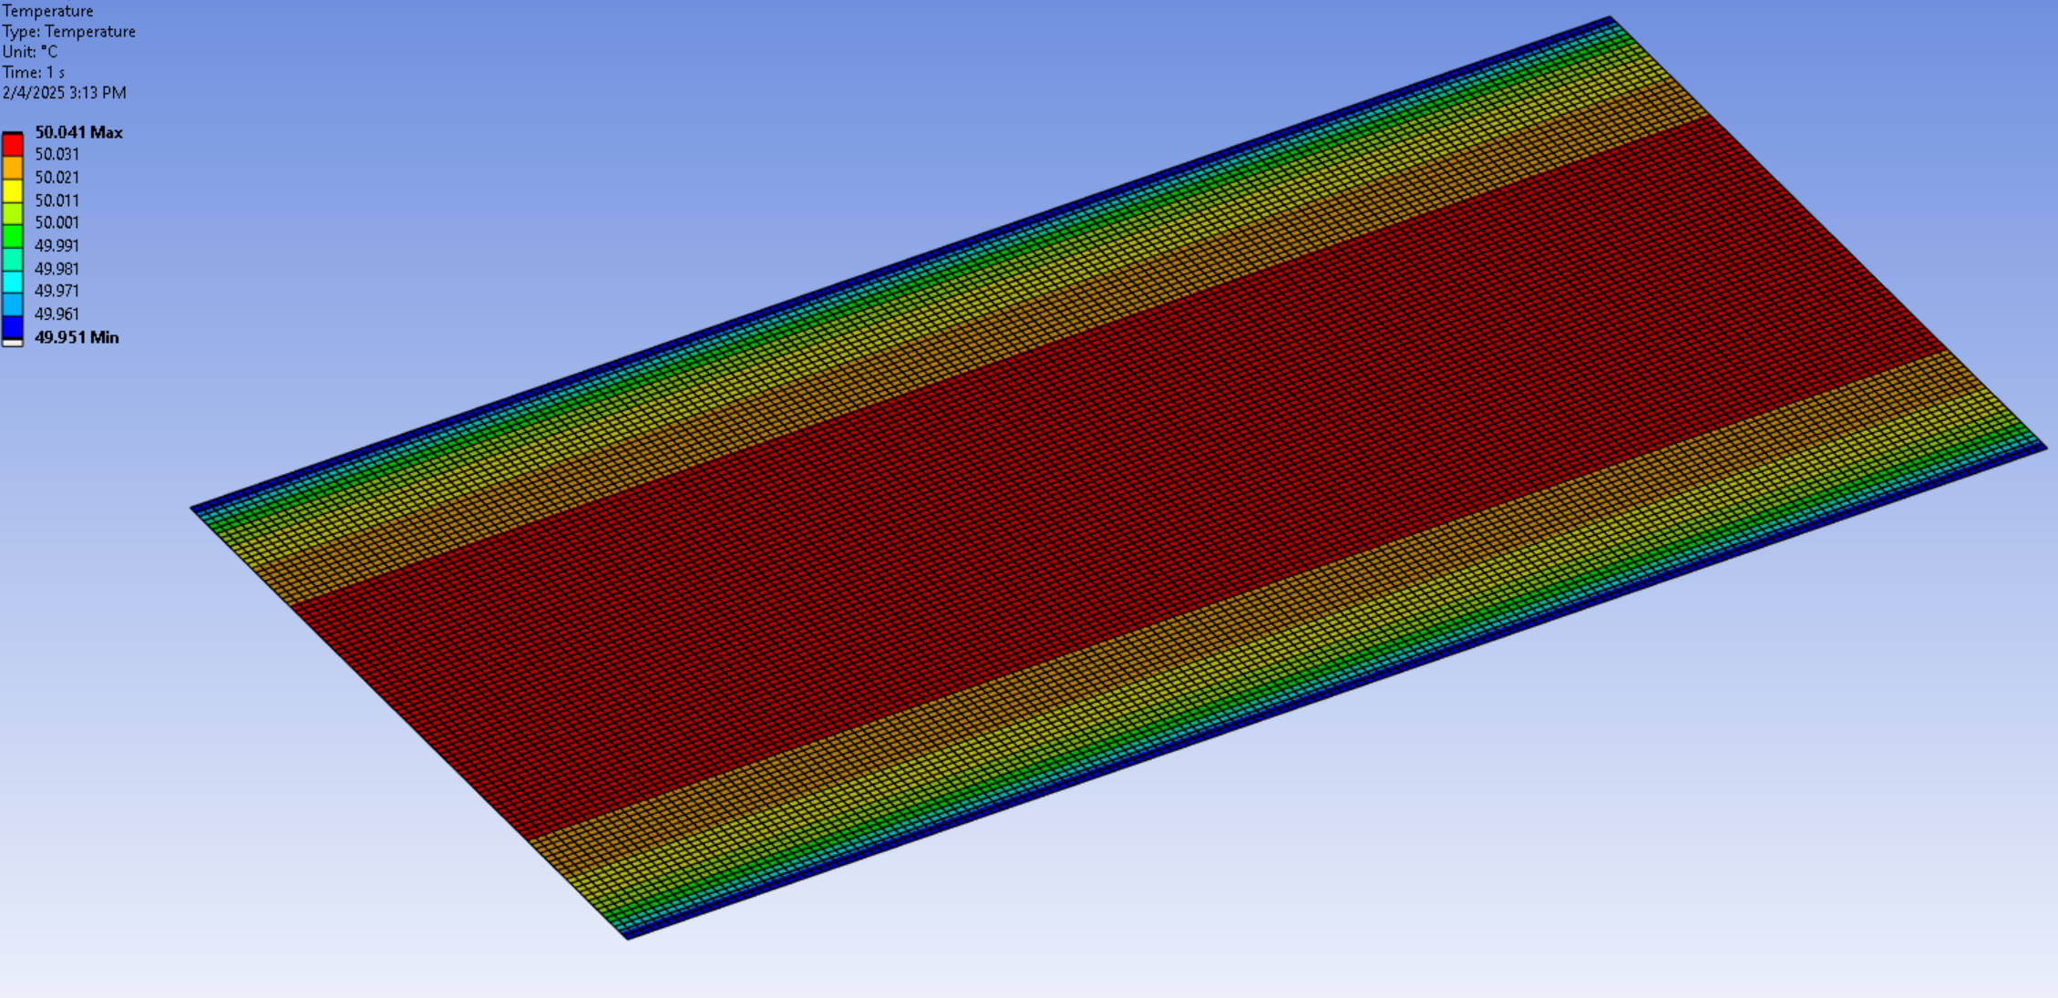

**4pm**

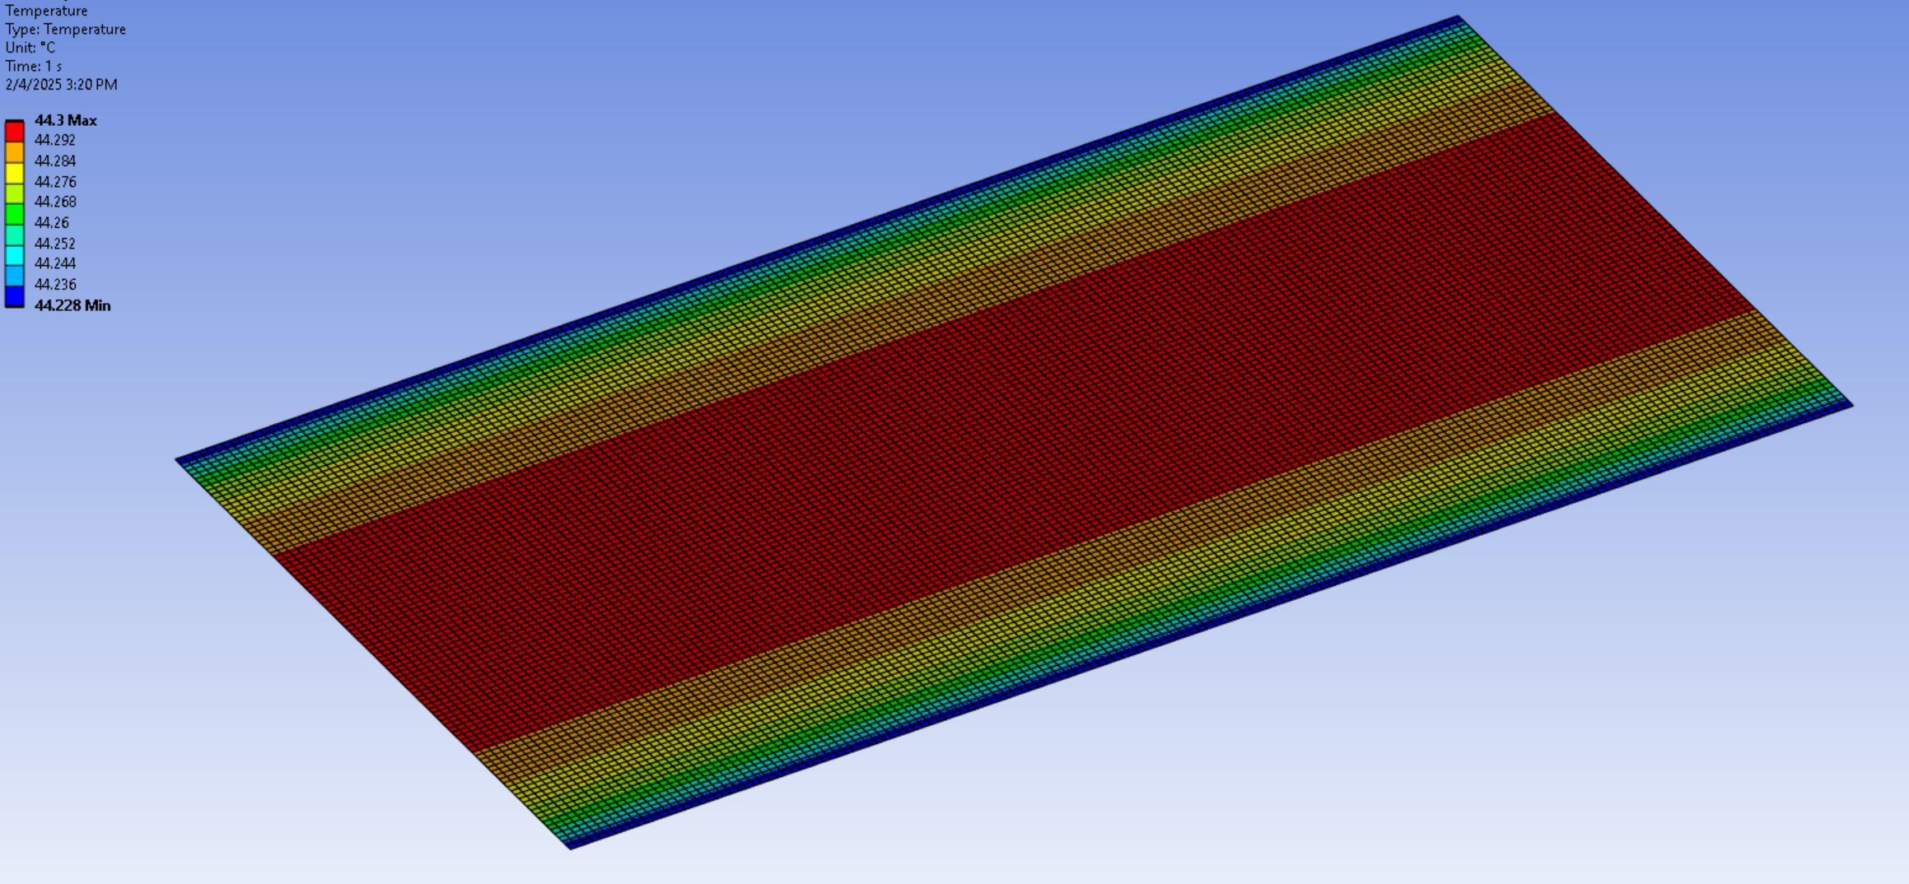

**5pm**

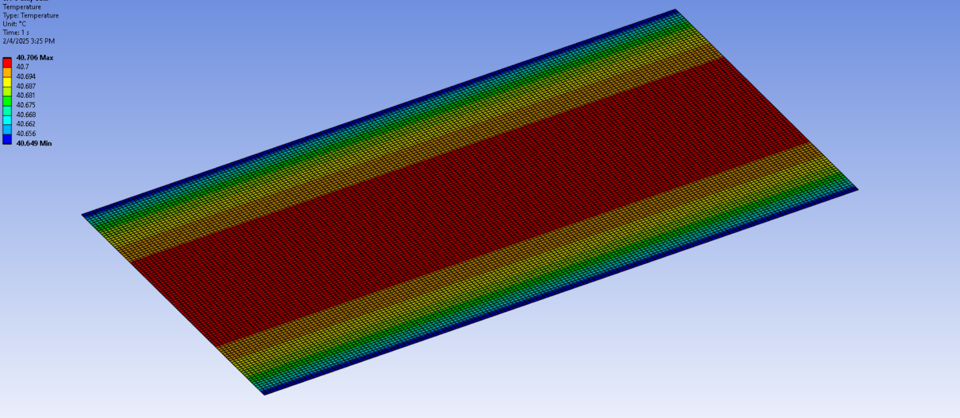

**Comparison between 4 dielectric fluids:**

**Novec**

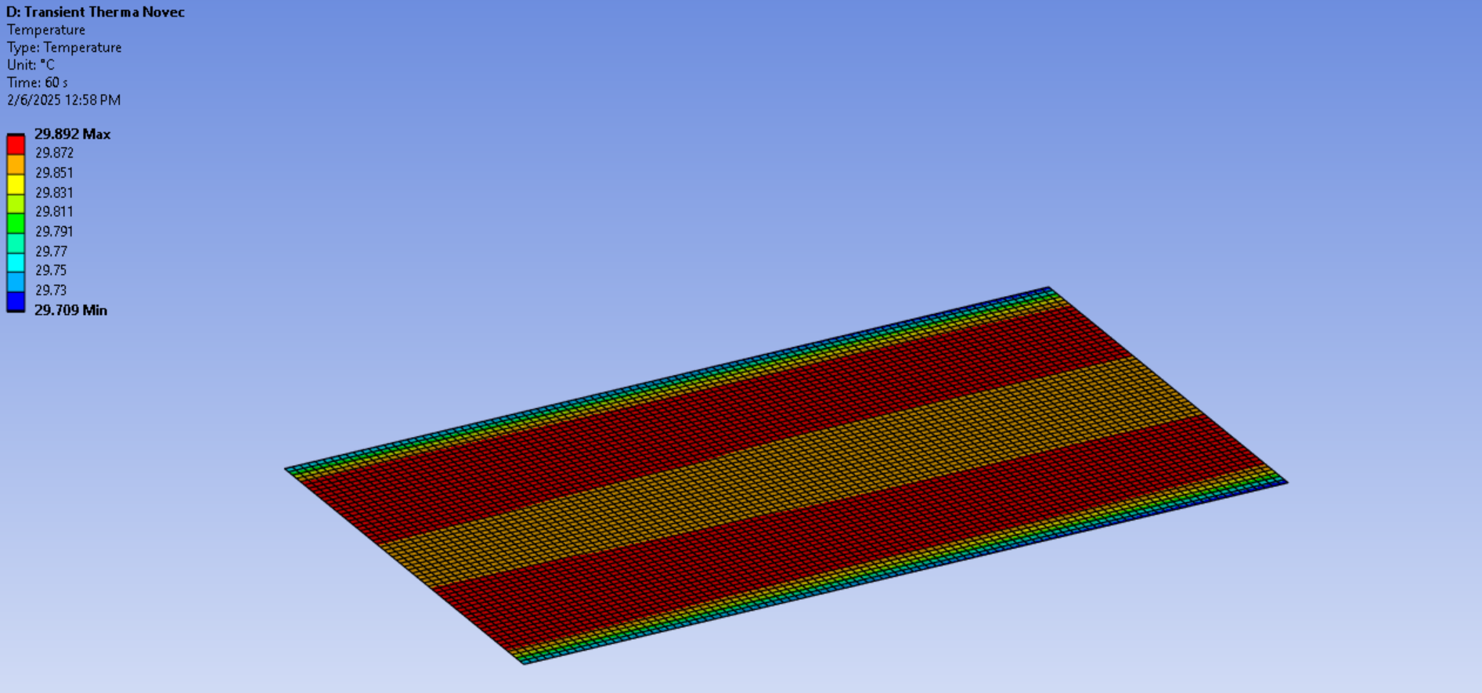

**Mineral oil**

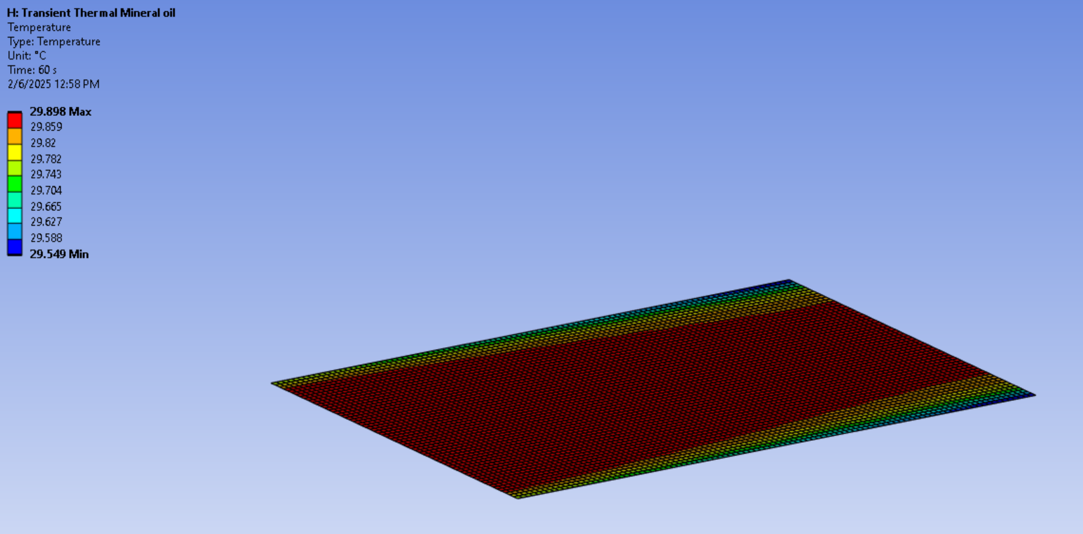

**Poly alpha oleffins**

**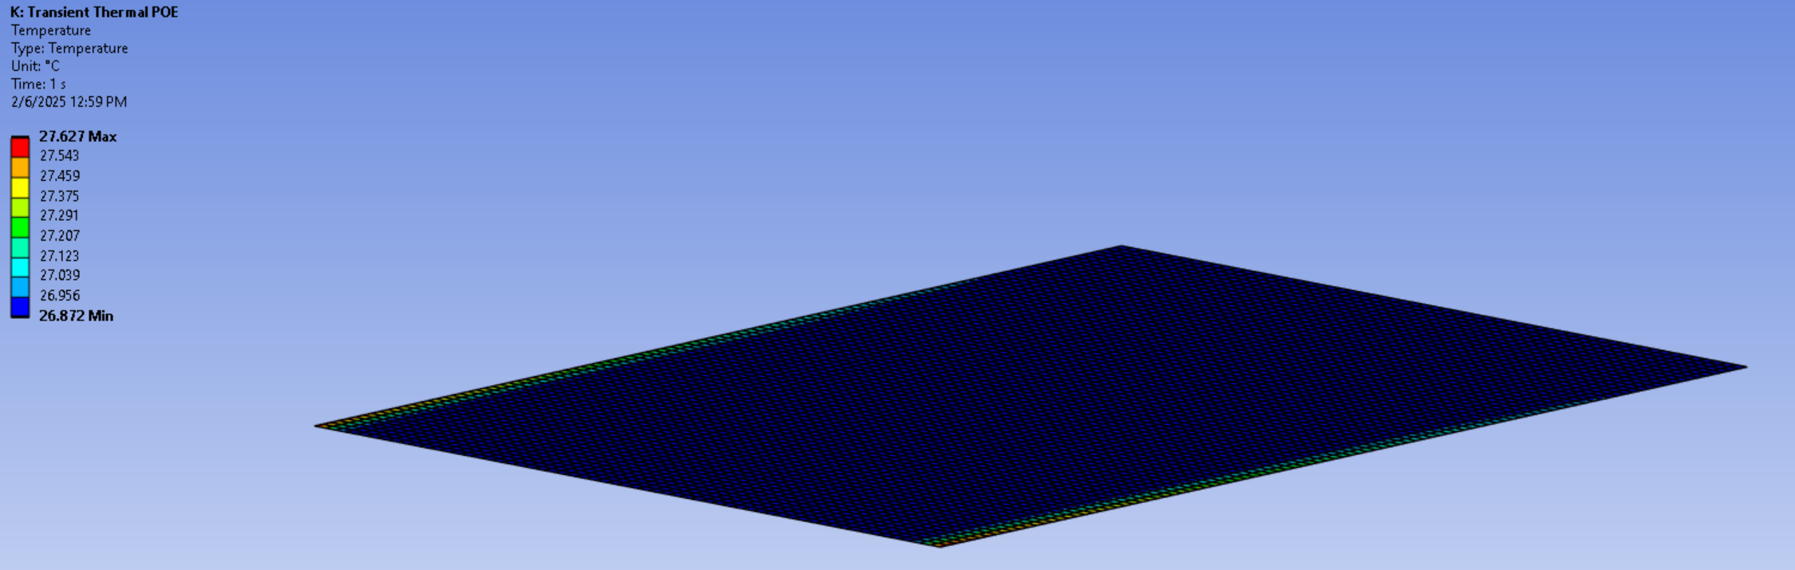  
Ester**

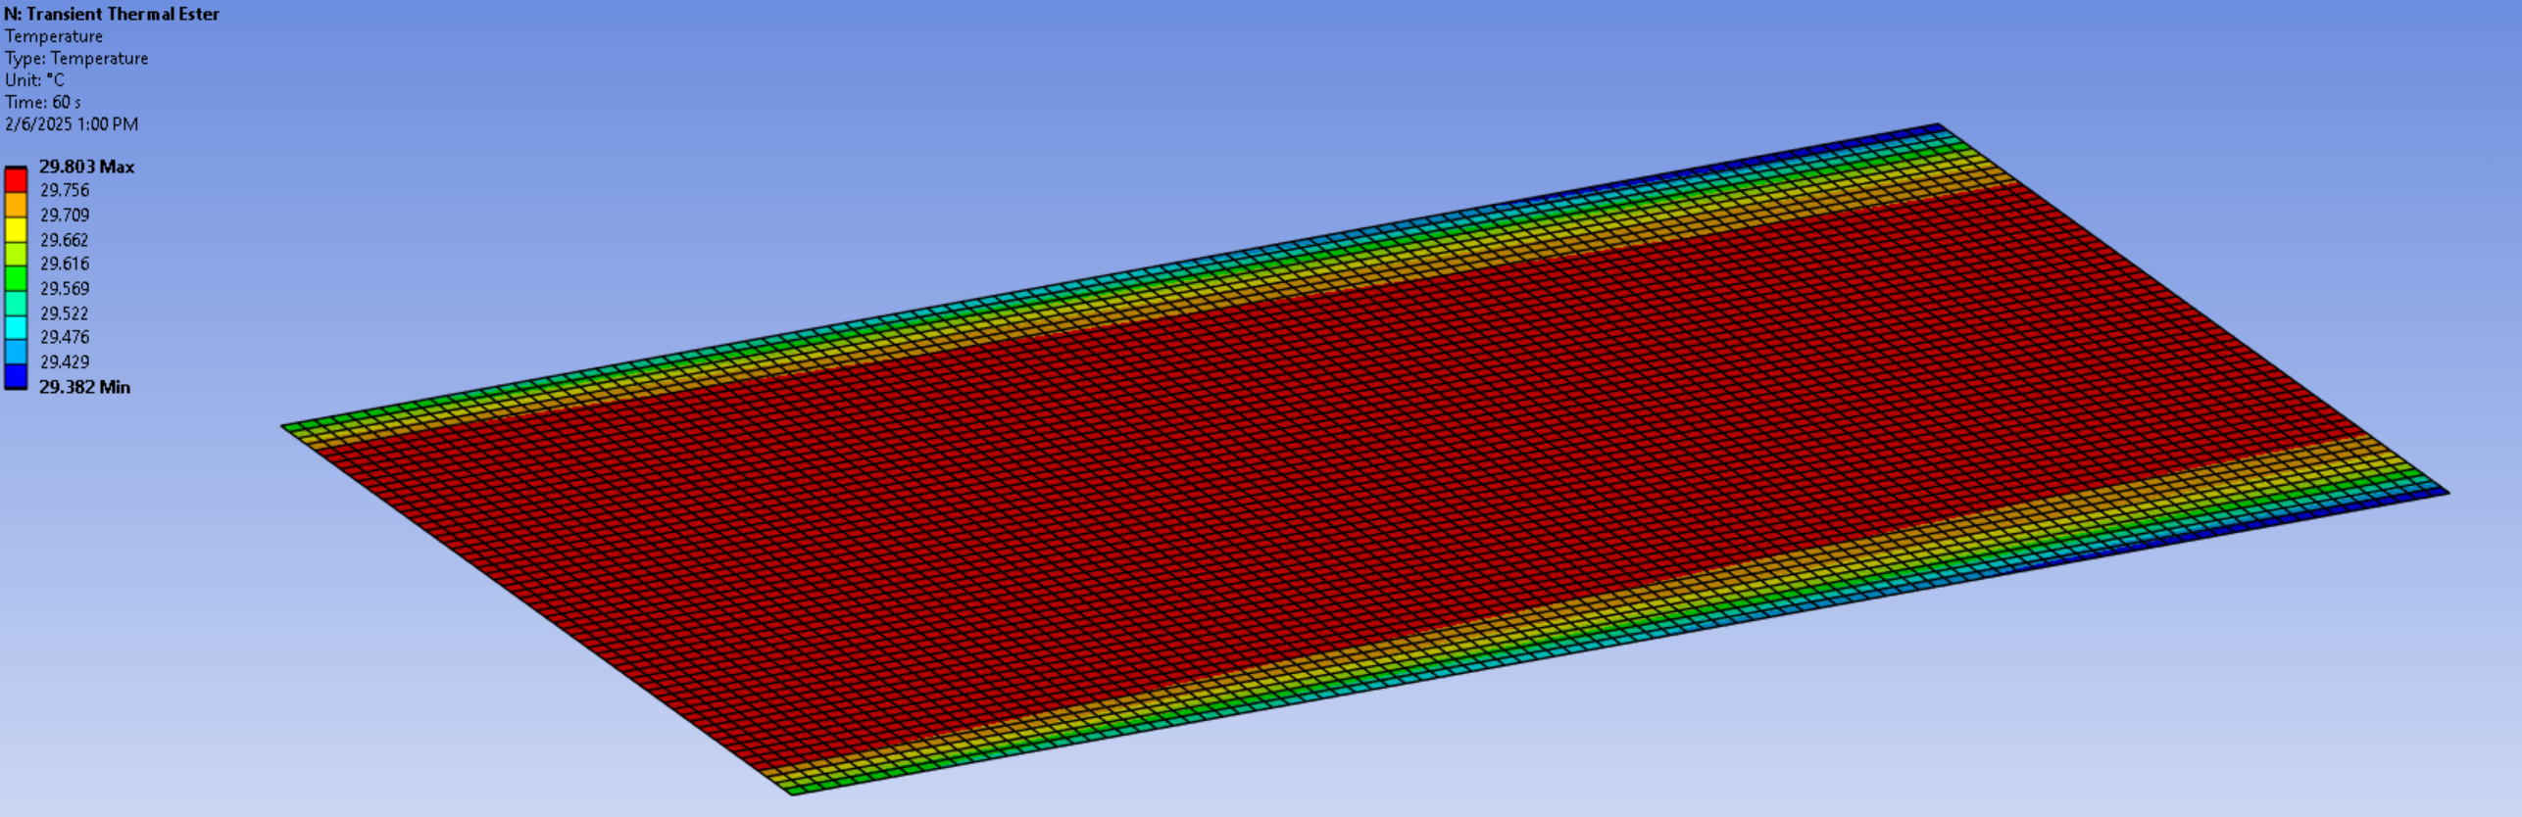

**PV with POE cooling (Vin =0.05m/s) :**

**8am**

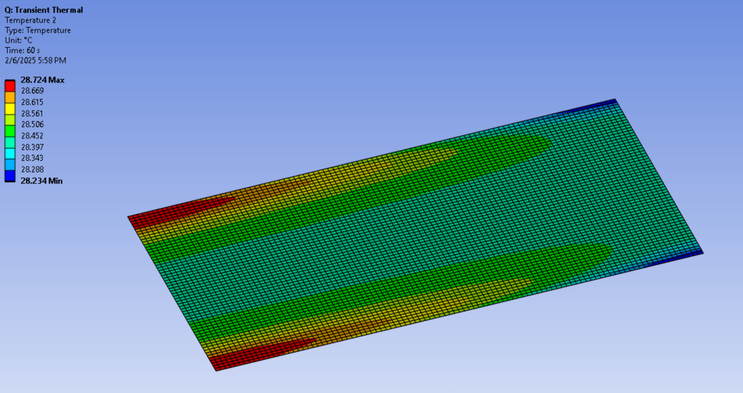

**9am**

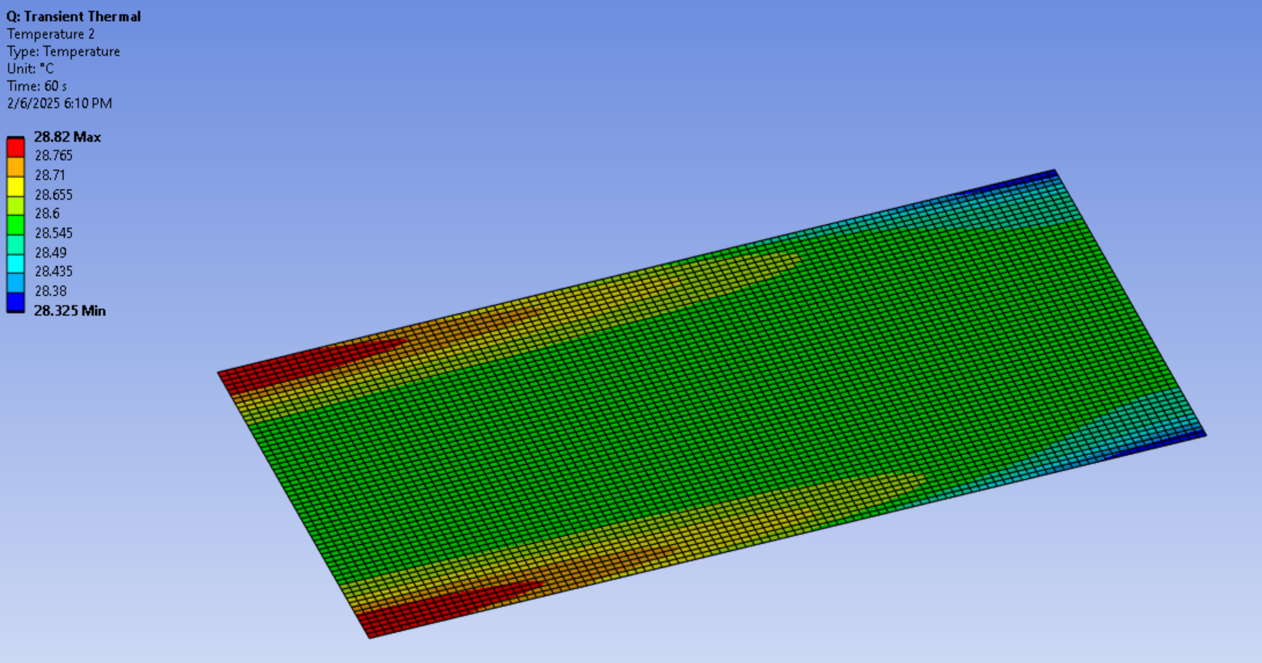

**10am**

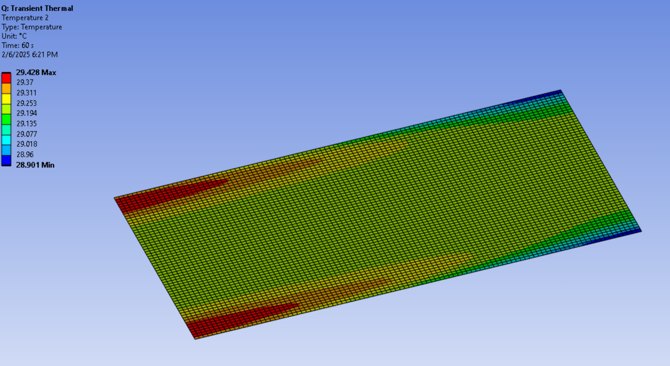

**11am**

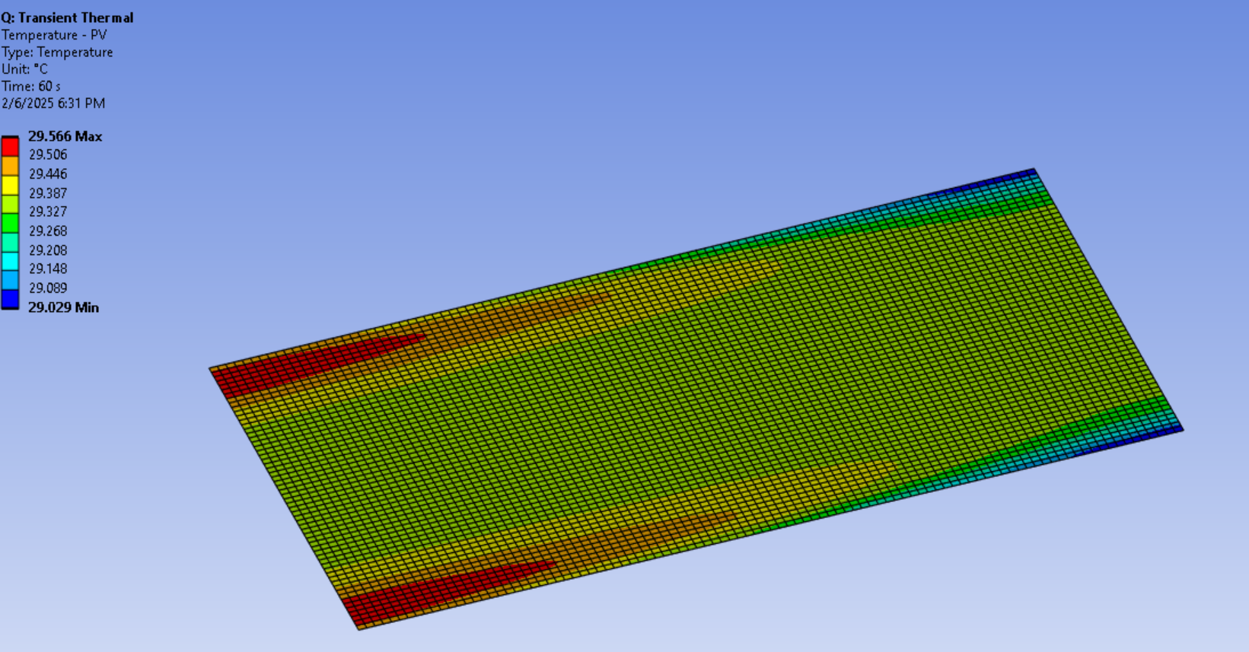

**12pm**

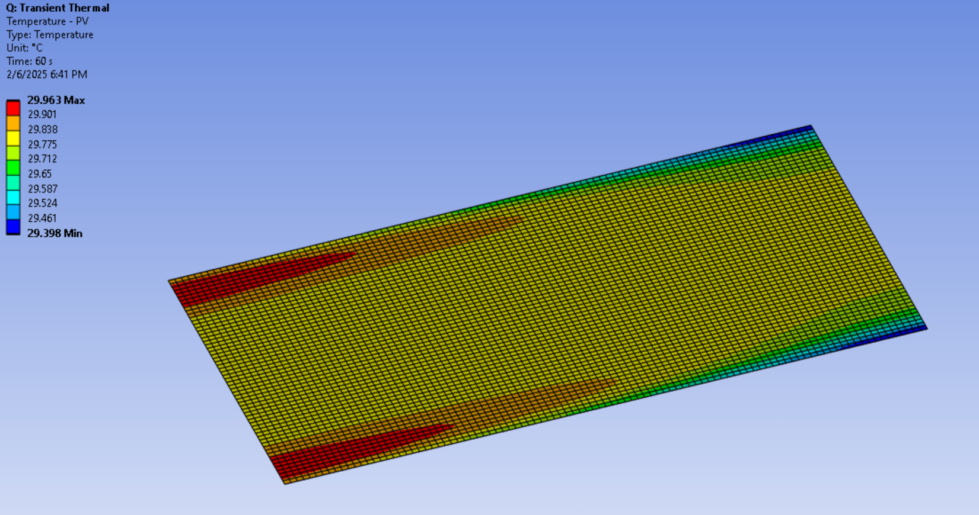

**1pm**

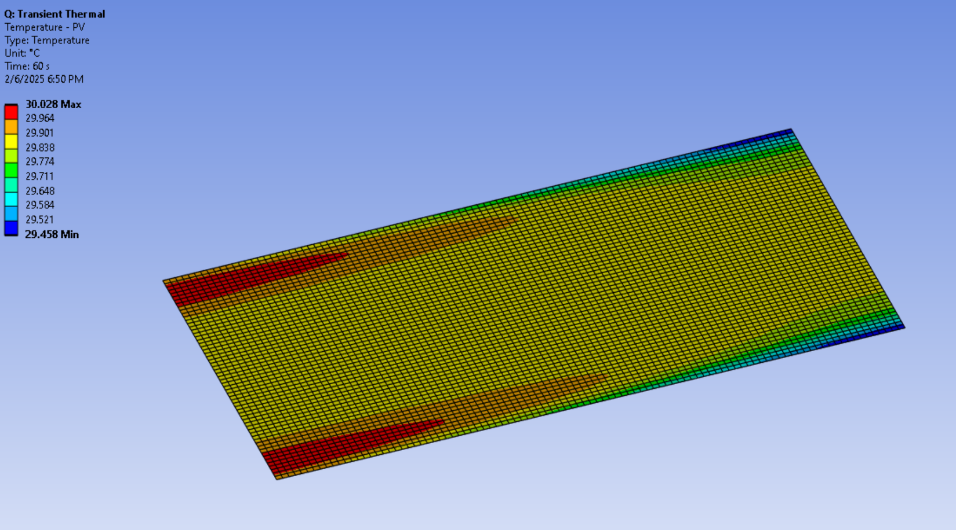

**2pm**

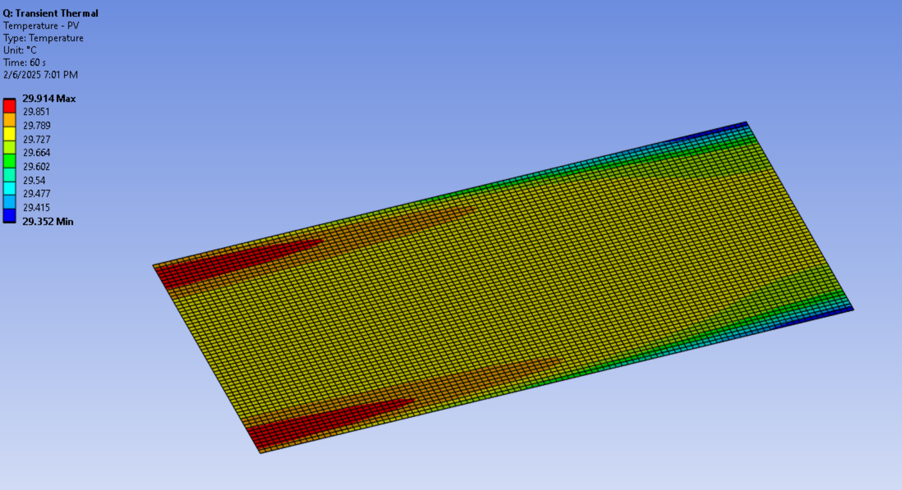

**3pm**

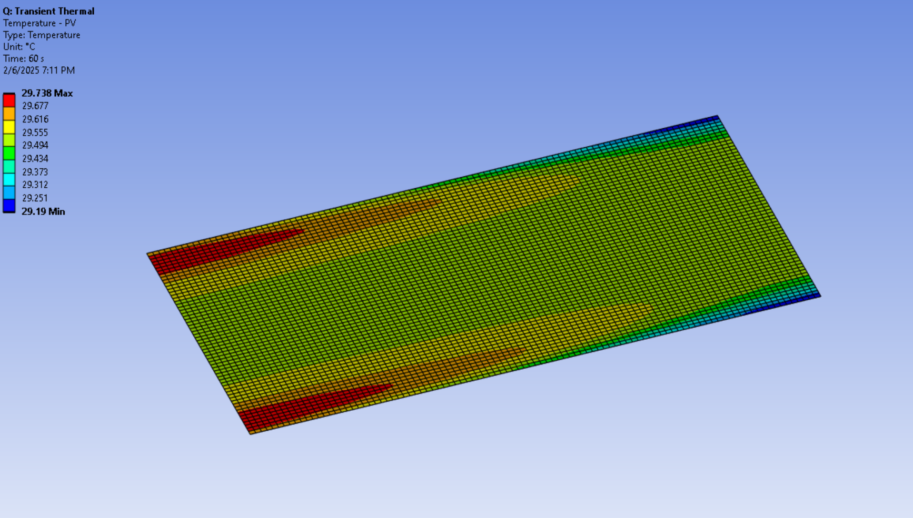

**4pm**

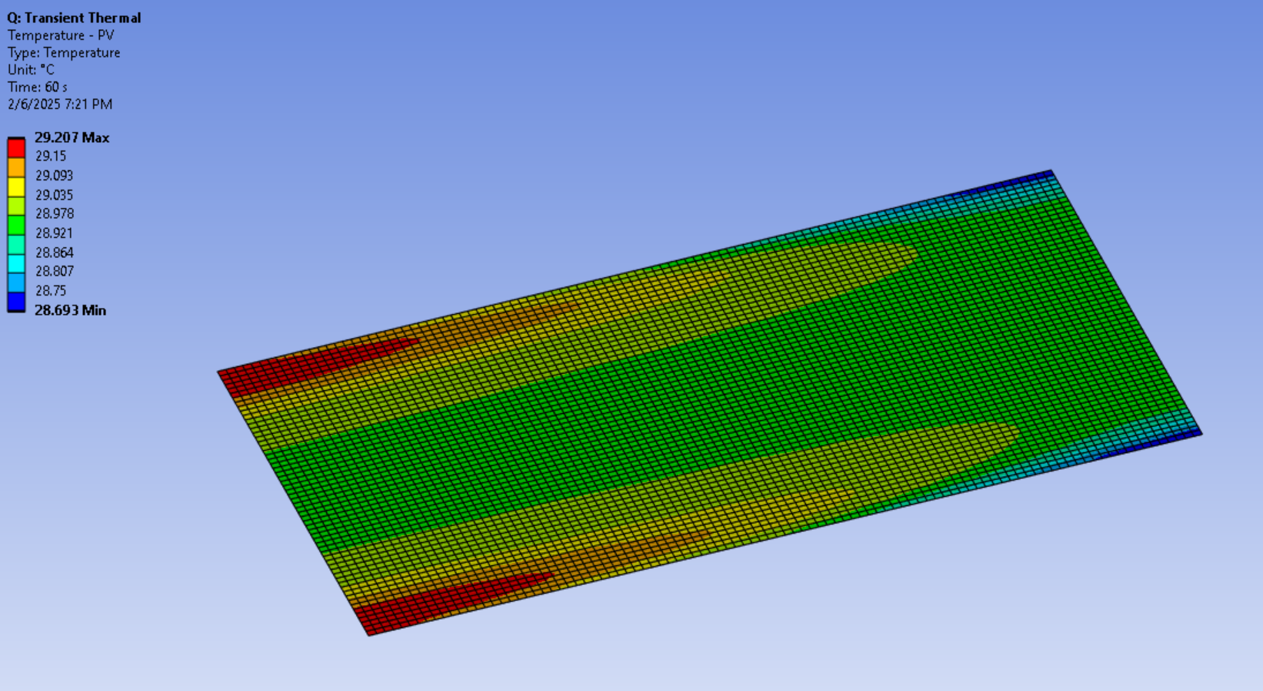

**5pm**

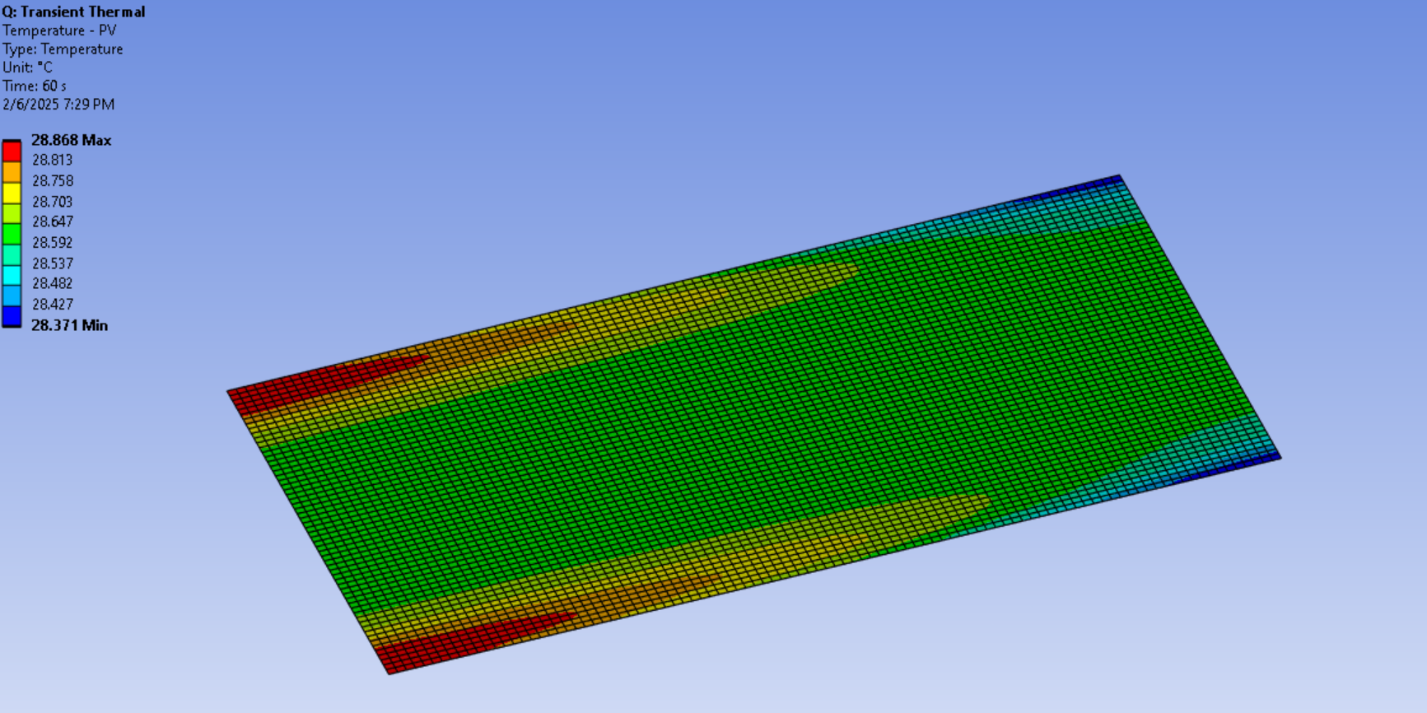

**Charts:**